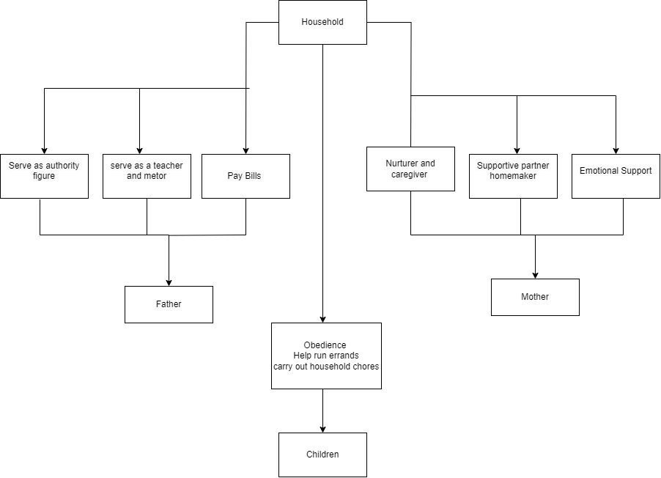

A CLASS DIAGRAM OF A TRADITIONAL HOUSEHOLD AND THE ROLES EACH MEMBER CARRY.

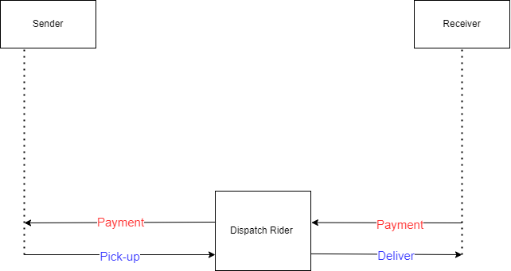

A SIMPLE SEQUENCE DIAGRAM DISPLAYING THE ACTIVITIES A DISPATCH RIDER WOULD HAVE TO TAKE TO COMPLETE WORK